Write a program using TCP socket for wired network for following

a. Say Hello to Each other
b. File transfer
c. Calculator
client.c:
#include <stdio.h>
#include <stdlib.h>
#include <string.h>
#include <unistd.h>
#include <arpa/inet.h>
#define PORT 8080
#define BUFFER_SIZE 1024
void sayHello(int sock) {
char buffer[BUFFER_SIZE] = {0};
char hello[] = "Hello from Client!";
send(sock, hello, strlen(hello), 0);
printf("Hello message sent\n");
recv(sock, buffer, BUFFER_SIZE, 0);
printf("Server: %s\n", buffer);
}
void fileTransfer(int sock) {
char buffer[BUFFER_SIZE] = {0};
char *filename = "client_file.txt";
FILE *file = fopen(filename, "r");
if (!file) {
perror("Error opening file");
return;
}

int bytes_read;
while ((bytes_read = fread(buffer, sizeof(char), BUFFER_SIZE, file)) > 0) {
send(sock, buffer, bytes_read, 0);
}
fclose(file);
printf("File sent successfully\n");
}
void calculator(int sock) {
char expression[BUFFER_SIZE] = {0};
char result[BUFFER_SIZE] = {0};
printf("Enter a mathematical expression (e.g., 5+3): ");
fgets(expression, BUFFER_SIZE, stdin);
expression[strcspn(expression, "\n")] = 0;

send(sock, expression, strlen(expression), 0);

recv(sock, result, BUFFER_SIZE, 0);
printf("Result from server: %s\n", result);
}
int main() {
int sock = 0;
struct sockaddr_in serv_addr;
if ((sock = socket(AF_INET, SOCK_STREAM, 0)) < 0) {
printf("Socket creation error\n");
return -1;
}
serv_addr.sin_family = AF_INET;
serv_addr.sin_port = htons(PORT);
if (inet_pton(AF_INET, "127.0.0.1", &serv_addr.sin_addr) <= 0) {
printf("Invalid address/Address not supported\n");
return -1;
}
if (connect(sock, (struct sockaddr *)&serv_addr, sizeof(serv_addr)) < 0) {
printf("Connection Failed\n");
return -1;
}
int option;
printf("Choose an option:\n1. Say Hello\n2. File Transfer\n3. Calculator\nEnter: ");
scanf("%d", &option);
getchar();
send(sock, &option, sizeof(option), 0);
switch (option) {
case 1: sayHello(sock); break;
case 2: fileTransfer(sock); break;
case 3: calculator(sock); break;
default: printf("Invalid option selected.\n"); break;
}
close(sock);
return 0;
}
Server.c
#include <stdio.h>
#include <stdlib.h>
#include <string.h>
#include <unistd.h>
#include <arpa/inet.h>
#define PORT 8080
#define BUFFER_SIZE 1024
// Function for sending and receiving "Hello"
void sayHello(int client_sock) {
char buffer[BUFFER_SIZE] = {0};
char hello[] = "Hello from Server!";
// Receiving hello message from client
recv(client_sock, buffer, BUFFER_SIZE, 0);
printf("Client: %s\n", buffer);
// Sending hello message to client
send(client_sock, hello, strlen(hello), 0);
printf("Hello message sent to client\n");
}
// Function for file transfer
void fileTransfer(int client_sock) {
char buffer[BUFFER_SIZE] = {0};
char *filename = "server_received_file.txt";
FILE *file = fopen(filename, "w");
if (!file) {
perror("Error opening file");
return;
}
int bytes_received;
while ((bytes_received = recv(client_sock, buffer, BUFFER_SIZE, 0)) > 0) {
fwrite(buffer, sizeof(char), bytes_received, file);
if (bytes_received < BUFFER_SIZE) break;
}
fclose(file);
printf("File received successfully\n");
}
// Function for calculator
void calculator(int client_sock) {
char expression[BUFFER_SIZE] = {0};
char result[BUFFER_SIZE] = {0};

recv(client_sock, expression, BUFFER_SIZE, 0);
printf("Expression received: %s\n", expression);
int num1, num2;
char op;
int calc_result = 0;
if (sscanf(expression, "%d%c%d", &num1, &op, &num2) != 3) {
snprintf(result, BUFFER_SIZE, "Error: invalid expression");
send(client_sock, result, strlen(result), 0);
return;
}
switch (op) {
case '+': calc_result = num1 + num2; break;
case '-': calc_result = num1 - num2; break;
case '*': calc_result = num1 * num2; break;
case '/': calc_result = (num2 != 0) ? num1 / num2 : 0; break;
default: snprintf(result, BUFFER_SIZE, "Error: invalid operation");
send(client_sock, result, strlen(result), 0);
return;
}

snprintf(result, BUFFER_SIZE, "%d", calc_result);
send(client_sock, result, strlen(result), 0);
printf("Calculation result sent: %s\n", result);
}
int main() {
int server_fd, client_sock;
struct sockaddr_in address;
int addrlen = sizeof(address);

// Creating socket
if ((server_fd = socket(AF_INET, SOCK_STREAM, 0)) == 0) {
perror("Socket failed");
exit(EXIT_FAILURE);
}
// Binding
address.sin_family = AF_INET;
address.sin_addr.s_addr = INADDR_ANY;
address.sin_port = htons(PORT);

if (bind(server_fd, (struct sockaddr *)&address, sizeof(address)) < 0) {
perror("Bind failed");
exit(EXIT_FAILURE);
}
// Listening
if (listen(server_fd, 3) < 0) {
perror("Listen failed");
exit(EXIT_FAILURE);
}
printf("Server is listening on port %d\n", PORT);

while (1) {
// Accept incoming client
if ((client_sock = accept(server_fd, (struct sockaddr *)&address,
(socklen_t*)&addrlen)) < 0) {
perror("Accept failed");
continue;
}
printf("Client connected!\n");

int option;
recv(client_sock, &option, sizeof(option), 0);

switch (option) {
case 1: sayHello(client_sock); break;
case 2: fileTransfer(client_sock); break;
case 3: calculator(client_sock); break;
default: printf("Invalid option selected.\n"); break;
}
close(client_sock); // Close client after handling
printf("Client disconnected.\n\n");
}

close(server_fd);
return 0;
}
OUTPUT
TERMINAL1:
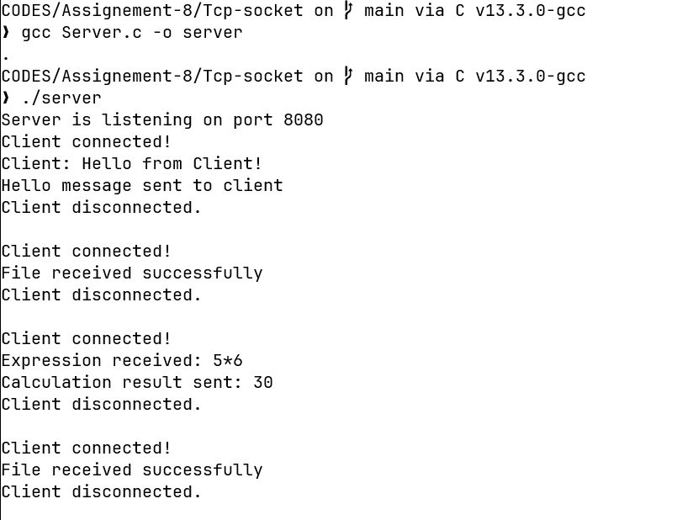

TERMINAL2;
